KiZAN IoT Workshop

Lab Exercises

# Lab 3 – Toggle LED On/Off

## Goal

The goal of this exercise is to build a simple push button circuit to toggle an LED on and off using a Windows IoT Core device (Raspberry Pi 2, in our case) and an app built and debugged with Visual Studio 2015.

## Requirements

Prior to starting this exercise, please ensure that you meet the following requirements. This exercise assumes that you have previously completed Lab 2.

### Hardware

Please verify that you have the following components:

1. Raspberry Pi 2 Model B w/ EDIMAX Wifi Adapter
2. Wall Adapter Power Supply
3. Raspberry Pi GPIO Ribbon Cable
4. SparkFun Pi Wedge Breakout Board
5. Breadboard
6. (1) Yellow LED
7. (1) Tactile Push Button Base with Yellow Button Head
8. (1) 330 Ohm Resistor
9. (4) Yellow Jumper Wires M/M
10. (2) Black Jumper Wire M/M

### Software

Please verify that you have the following software installed on your Windows 10 laptop:

1. Visual Studio 2015 Community Edition (or greater)

<https://www.visualstudio.com/vs-2015-product-editions>

1. Windows 10 IoT Core Dashboard

<https://developer.microsoft.com/en-us/windows/iot/downloads>

### Networking

To communicate with the Raspberry Pi 2, you must be connected to the following Wifi network:

|  |  |
| --- | --- |
| SSID | Password |
| iotlab | p@ssw0rd |

## Part 1 – Circuit Assembly

1. Wire the Yellow LED in a similar fashion to the Red LED in Lab 1, using the *G5* pin on the Pi Wedge Breakout Board.

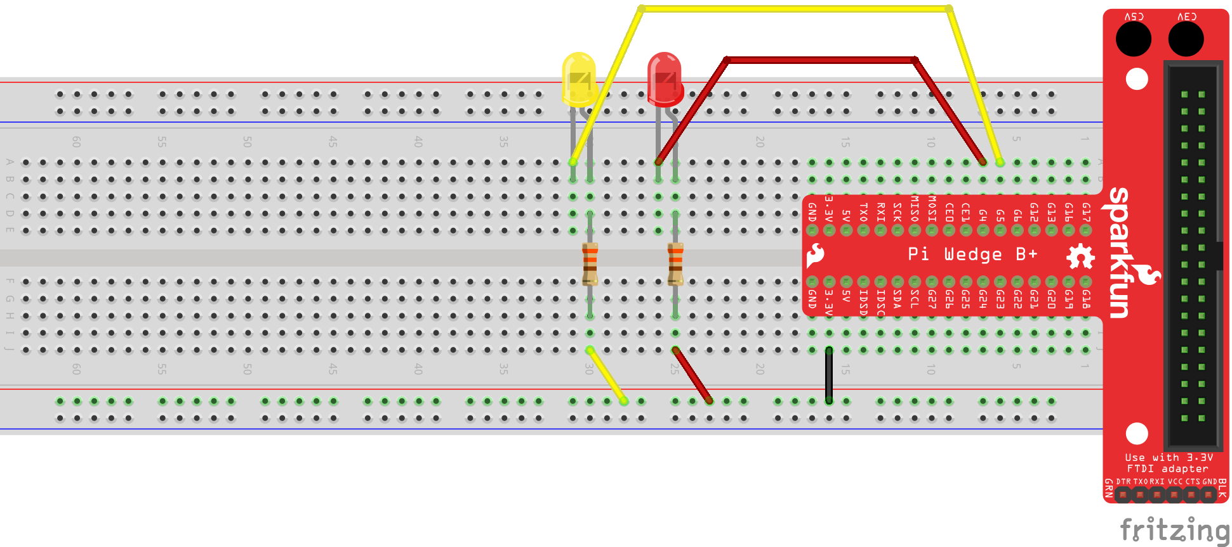

Figure - Yellow and Red LEDs

1. Place the base of the tactile push button on the Breadboard, spanning the middle line of the Breadboard. Note: the base of the push button requires a bit of “effort” to mount on the breadboard. When installed properly, it should sit flush with the breadboard. Once the base is in place, snap the button head onto the base.

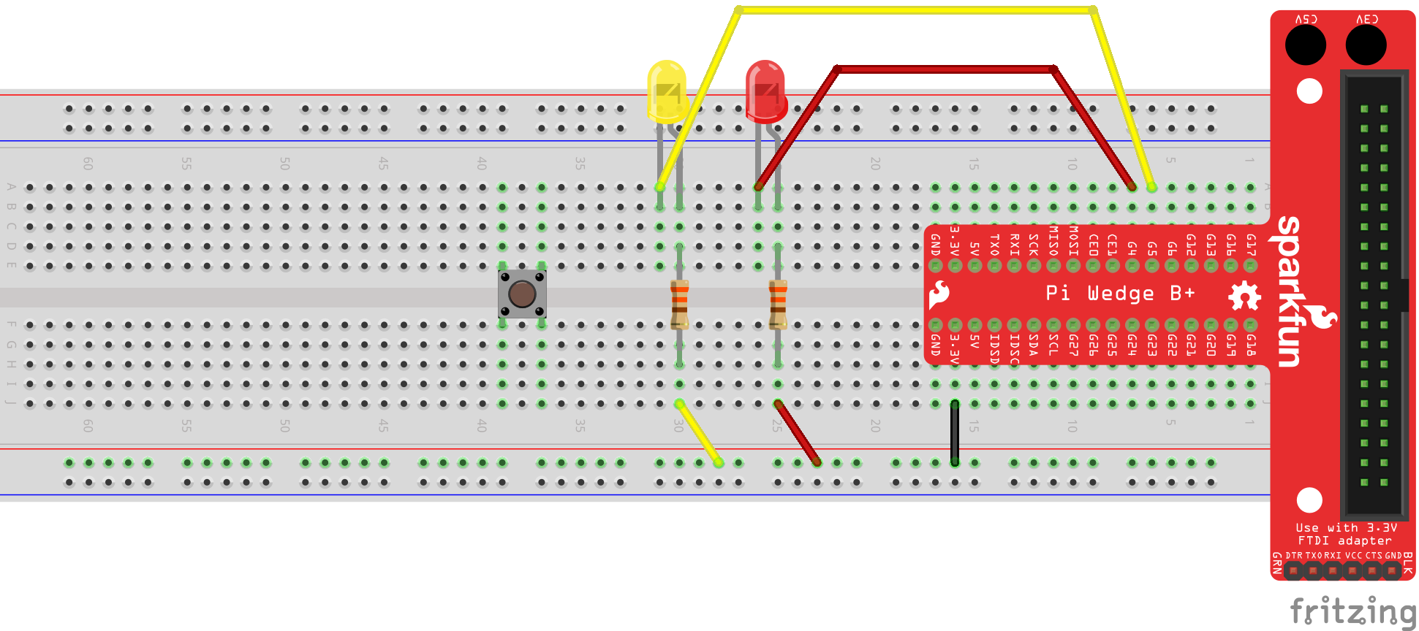

Figure - Push button placed on the breadboard

1. Using a Yellow Jumper Wire, connect one end to one of the top pins of the push button base. Connect the opposite end to the pin labeled *G6* on the SparkFun Pi Wedge Breakout Board.

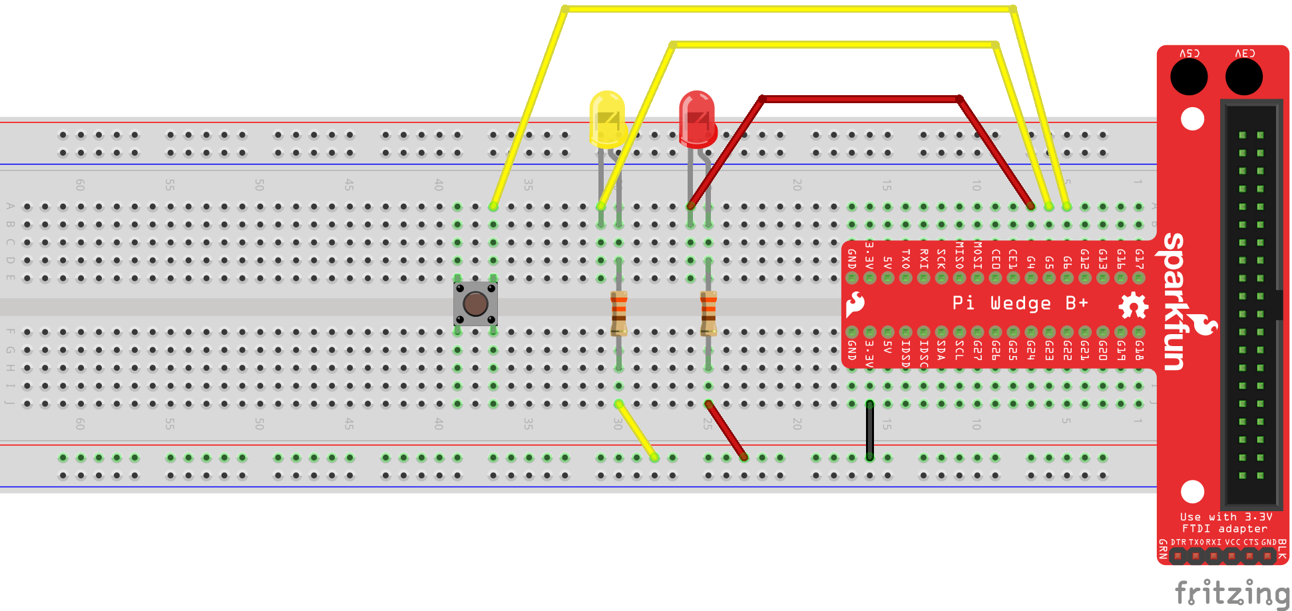

Figure - Push button connected to G6 pin of the Pi Wedge

1. Using a Yellow Jumper Wire, connect one end to one of the bottom pins of the push button base. Connect the opposite end to the negative (-) channel of pins located on the bottom of the breadboard.

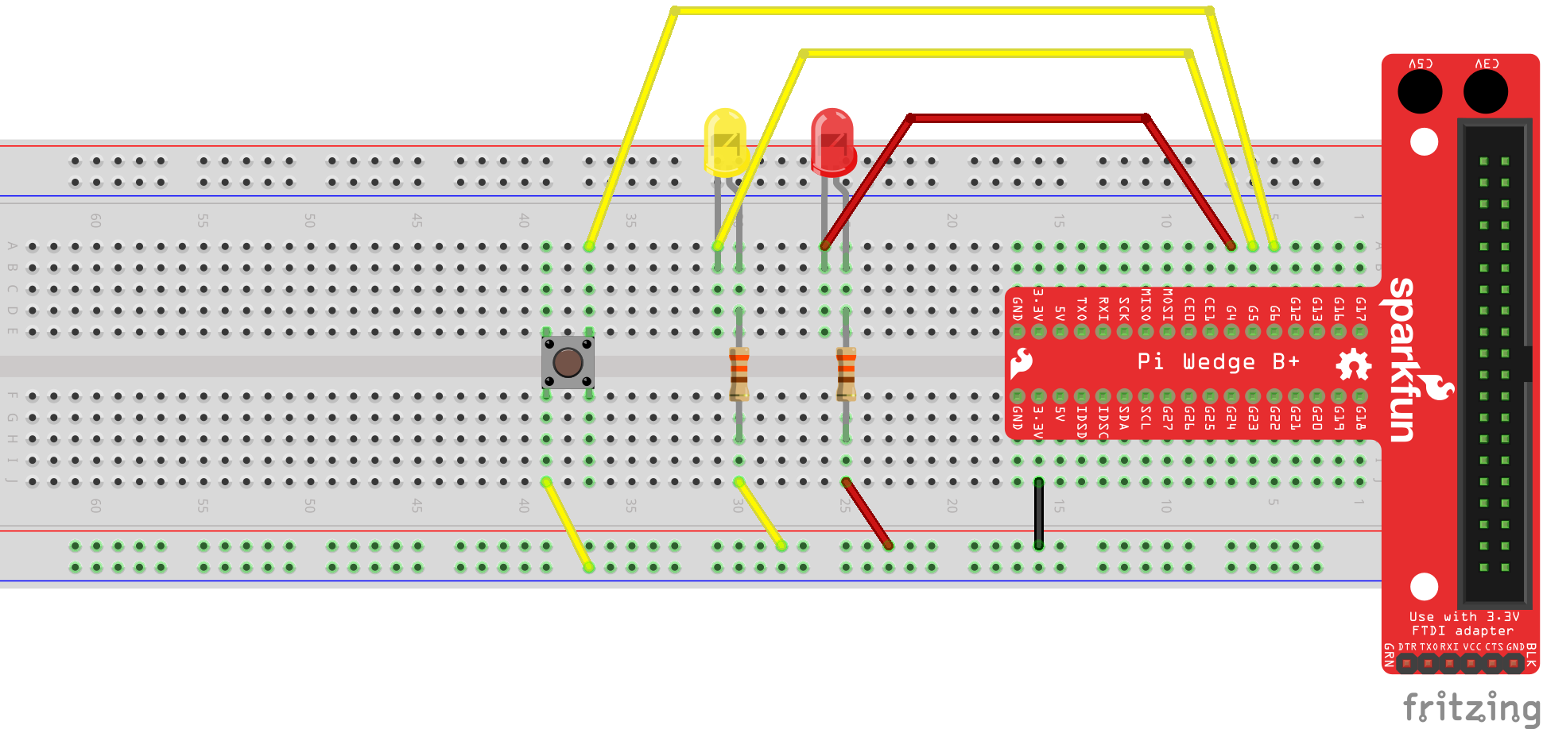

Figure - Push button connected to the negative pin channel

1. Using a Black Jumper Wire, connect the negative (-) channel of pins to the pin labeled *GND* on the SparkFun Pi Wedge.

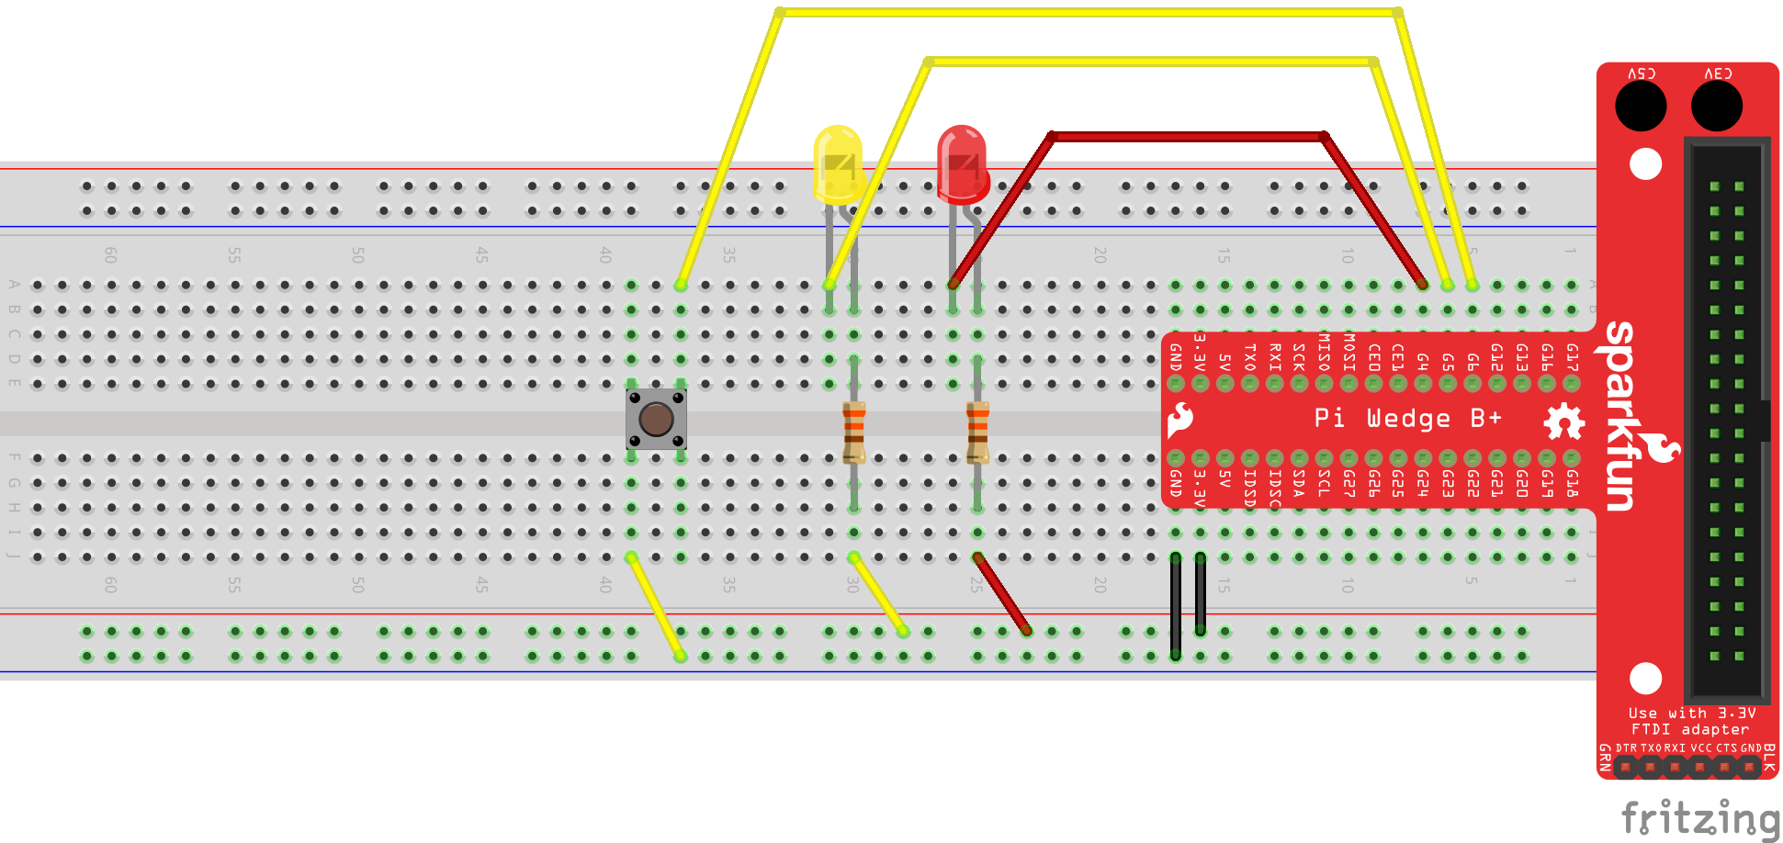

Figure - Negative (-) pin channel connected to GND pin on the Pi Wedge

## Part 2 – Code

1. Connect the Wall Adapter Power Supply to the micro USB port on the Raspberry Pi. Next, plug in the Wall Adapter Power Supply.
2. Open the Windows 10 IoT Core Dashboard application. Once your device has completed its power up sequence, you should see your device in the list of *My devices*.

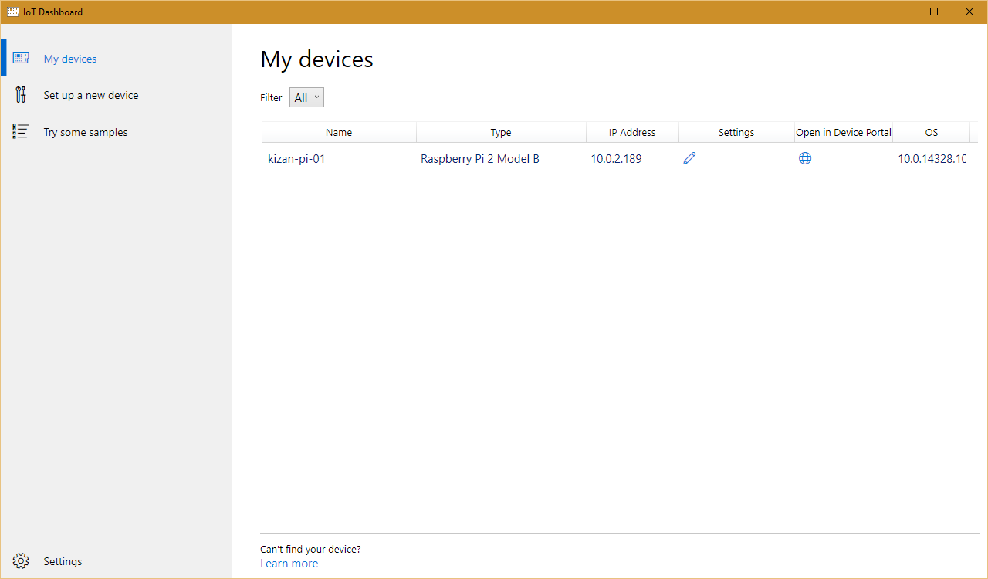

Figure 12 - Windows 10 IoT Core Dashboard

1. Using Visual Studio 2015, open the Lab02.sln solution from the downloaded source package. Lab02.sln is located in the *KiZAN-IoT-Workshop\src\Lab02* folder.
2. Verify that the Debug configuration and ARM platform are selected.



Figure 13 - Build Configuration and Platform

1. Next, change Run from Device to Remote Machine.

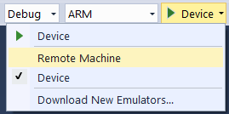

Figure 14 - Change Run from Device to Remote Machine

1. In the Remote Connections dialog box, find your device in the list of Auto Detected devices. Select your device, and click the Select button.

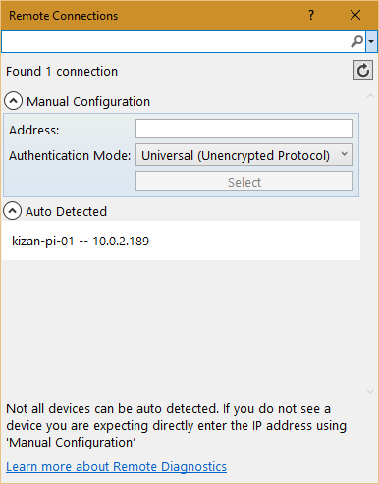

Figure 15 - Remote Connections

1. Press F5 to run the application. Visual Studio will restore any missing NuGet packages, build the application, and then deploy the application to the remote machine. Shortly after deploying the application, you should observe the Red LED blinking intermittently.
2. Next, push the Yellow Push Button to toggle the Yellow LED on and off.
3. Stop debugging.
4. Using Windows 10 IoT Core Dashboard, click the globe icon in the *Open in Device Portal* column for your device.
5. When prompted enter the following User Name and Password.

|  |  |
| --- | --- |
| User Name | Password |
| Administrator | p@ssw0rd |

1. In the upper, right-hand corner, click Power, and then click Shut down.

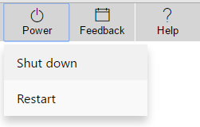

Figure 16 - Power Menu

1. When prompted to confirm, press OK.
2. It is safe to remove power when the Device Portal prompts to “Restart the device to reconnect”.